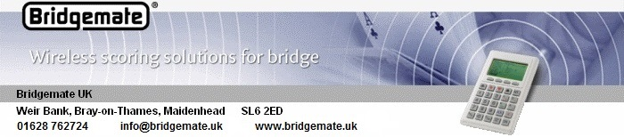

Bridgemate Refurbishment [2025]

General

Bridgemate handsets are robustly constructed and are designed for a working life of several years. Ten years or more is not at all unusual.

But in the course of multi-year usage, certain handset components are subject to wear, and this can mean that performance becomes less than optimal. However, our repair and refurbishment process can restore handsets to their original optimum operability.

Wear and Tear

The Bridgemate keypad has small pressure pads on the reverse side of each key. As a key is pressed the pressure pad makes contact with the corresponding key sensor on the printed circuit board [pcb]. Over a period of years, the key legend visibly fades, the pressure pad wears, and deposits from the pad build up a film on the key sensor. As a result it can become more difficult, especially for the most-used keys, for the keys to register.

Dealing with this aspect of wear involves thoroughly cleaning the pcb sensors and replacing the keypad. The cost to do this is £25 plus Vat.

The rubber feet on the reverse of the handset, which are designed to cushion the key-pressing impact, can wear completely flat after several years usage. They can be replaced at a cost of £12.50 plus Vat for a set of four.

Even where the keypad itself is not exhibiting signs of wear, handset performance can still benefit from a thorough clean, including the pcb key-sensors as mentioned above. This costs £15 plus Vat.

It’s in the nature of lcd screens that they can occasionally develop permanent blemishes. This is a fairly rare happening, but an affected screen can be replaced at a cost of £32.50 plus Vat. Handset cleaning is also included in this operation.

All cleaning operations include the lcd screen, and also incidentals such as the results of coffee spillage. All cleaning and refurbishment include a thorough test of the handset involved.

Wireless Frequency Adjustments

The Bridgemate server operates at a wireless frequency depending on the channel setting. Wireless circuitry can stray slightly from its initial frequency over the years. The wireless circuitry of the handsets incorporates an automatic fine-tune capability designed to track such frequency-straying on the part of the server. Handsets which are returned to ourselves for refurbishment or repair have their fine-tune setting checked, and if necessary reset.

Postage and Packing

Postage and packing for handset return is additionally charged at cost.

